FTP Posting
Occasions (Every 10th of the month)
60% to 99% Submittal : FIVE Months Prior
100% : TWO Months Prior
Final Posting : ONE Month Prior

How to Make Watermark
  - Settings are Center, Rotation 30°, Opacity 25%, Scale 80%
PRELIMINARY-SUBJECT TO CHANGE
NOT FOR BIDDING PURPOSES- MM/DD/YYYY
(You can save the watermark for your future addition of watermark in Save Setting.)

Nomenclatural System: CSJ, County, Preliminary %, Road Name, Description – File Name

Folder Location (where to save)
All FTP files are saved under T:\YKMCONST\FTP

60-95% Preliminary- WATERMARK ALL (Even if you are using 95% +, just name the files as 95%)
- Plans-Highest submittal we have (No Signatures, No Seals)
- E&Q Sheet or Estimate – NO PRICES
- Working Day Chart
(Note: 60%-99% are posted for big projects. Regular projects are posted between 90 to 99%.)

100% Preliminary- WATERMARK ALL (Even if you are using 100% +, just name the files as 100%)
- Plans- (Seal & Signatures are OK)
- E&Q Sheet or Estimate – NO PRICES
- Working Day Chart
- Cross Sections – If you have them (Just Bridges)
- Needs to send an email when finished as Preliminary Plans Posting for MM/YYYY Letting

Final Posting- NO WATERMARK
    - As Builds – In the Project Folder. If not, go to Plans-Online, and save all the ***-**.
    - Working Day Chart – In the Project Folder (Get the highest percentage)
    - Cross Sections – In the Project Folder (Get the highest percentage)
    - Geotech Report – Available ONLY for bridges. Use the Final version.
    - Needs to send an email when finished as Final Plans Released for CSJ and Addendum Deadline

FTP Posting
- Host: FTP.dot.state.tx.us (username: *** Password: ***)
- Left Side – Computer View (Local Files), Right Side – FTP Site View
- Drag and drop.

Bluebeam
- All documents must be in PDF version.
  - Create New Session (+)
    - File Name
Create new project Session
- Name the session using CSJ and Description (CSJ, County, Percentage, Road Name, Description)
- User Access – Uncheck Restricted Access
- Set end date for 2 weeks out. (If you are sending out more than two Bluebeam sessions in the same day, make a session due time gap at least an hour apart from each.)
- Add files under Documents.
  - Click “+”
- Click:

- Copy link to paste in Meeting invite (Microsoft Outlook)

Create Meeting Invite:
- Paste the Meeting Invite link from Bluebeam (also include who is submitted the submittal in the text box.)
- Type Meeting Title, and add People as shown in the figure.
- Location: NO MEETING

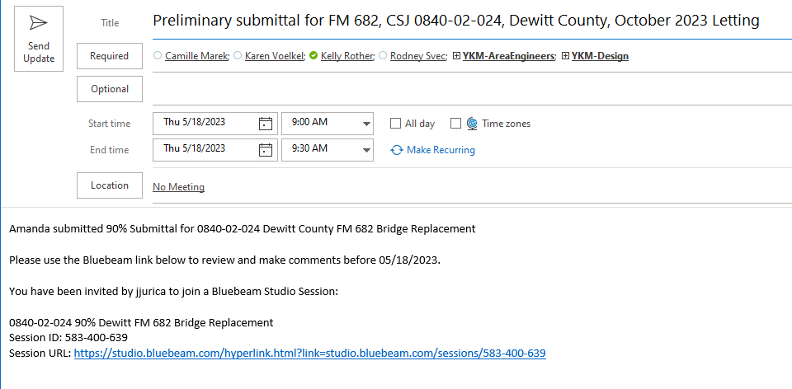

- Create a PDF copy of the Meeting Email Invite with the filename format ‘xxx-xx-xxxx, submittal % Comment Review Email.pdf.’ Save it in the Project Folder, naming the subfolder ‘Submittal %, Comments’ if it doesn’t already exist.

Estimate Vs. Authorized – to see if over 10% Rule
Occasions
Every time the submittal is received for internal review through Bluebeam (when Bluebeam invite is received)
  - Use Daily pull (the most recent version, sometimes, is called tableau)
  - Sort the project by using drop-down menu of CSJ Column Name.

Calculation
  - In Column P, substitute the column title as Authorize Amount.
  - In Column Q, rename it as Estimate, the data can be obtained from TXDOT Connect or from the project folder.
  - In Column R, rename it as Difference. Remove all the data that is originally existing.
  - In Column S, rename it as Difference %. Remove all the data that is originally existing.

  - Sum all the Authorize Amount shown in the tab.
  - Sum all the Estimate.
  - To calculate the Difference, Use the Formula (R=P-Q)
  - To calculate the Difference %, Use the Formula (S=R/P), convert it into percentage.
(Note: color the text if it goes over 10% limit.)

- If the percentage is less than or equal to 10%, there’s no need to send an email. However, if it’s greater than 10%, send an email
(Email format is as shown in the figure)

Email
To: Project Manager
CC: Engineering Supervisor of Transportation Design & Advanced Planning, TP & D
Subject: Estimate Vs. Authorized - % Submittal for CSJ, Description, County, letting MM/YY
Textbox: Typed as shown in the figure.

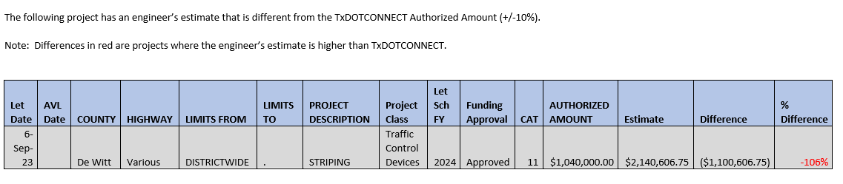

Ending Bluebeam Session
- Click on the link from Bluebeam email – or open Bluebeam and click on CSJ.
- Right click on CSJ
- Finish Session
  - Select the folder where the comments report will go (Submittal Comment Folder)

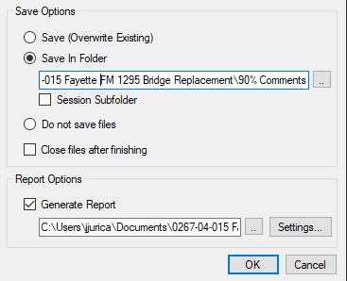

- Rename each file that was added with the word Comments in front of it.

(If you are not able to follow the above shown procedure, you can always press CTRL+P to print as pdf and save it to the project comment folder for each file pertained in the session. But the print setting must be changed as necessary such as landscape view, tabloid paper output, fit to print screen, etc.)

Notice to PM about Bluebeam Session is Ended
- CC – Engineer Supervisor, and Plan Reviewers (Sample Shown in figure.)
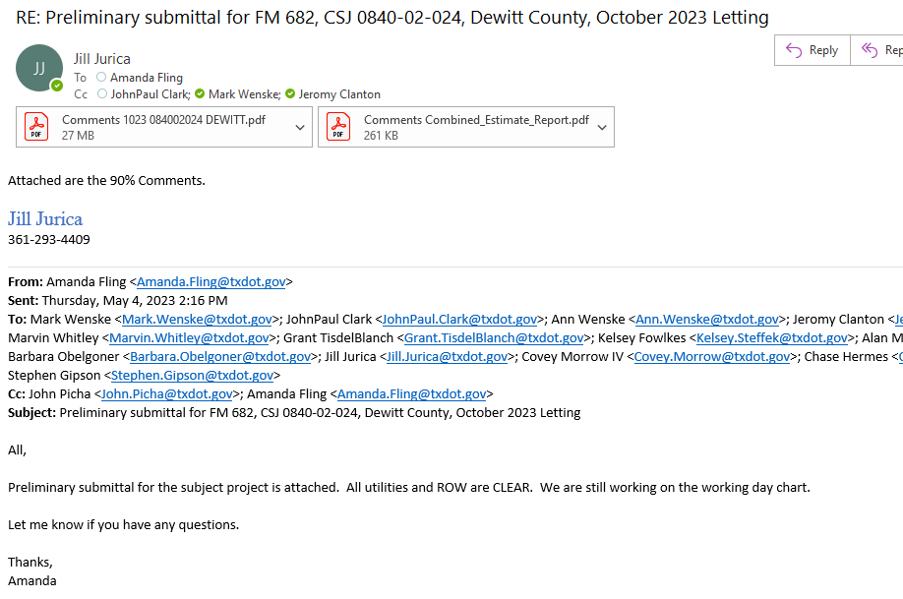

Updating on Project Wise:
  - Add the comment files from the project folder to Project Wise under the CSJ/Design/Plan Review/## Percent – Just drag and drop into folder.
Email Samples for FTP Postings
- Always include the Files Uploaded and ALL Pre-let Questions and Comments for Final Plan submitting email. (Project Specialist usually have that spreadsheet.)
- Check the Addendum Deadline in TXDOT Connect.
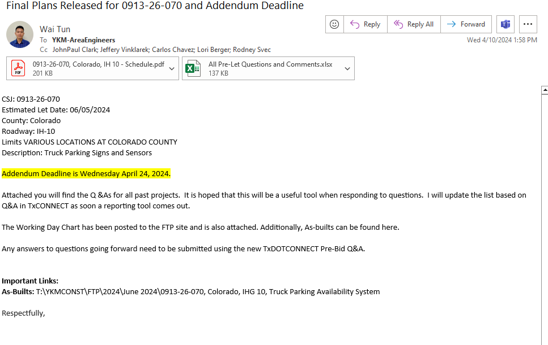
- For Preliminary Postings, we don’t include the files uploaded.
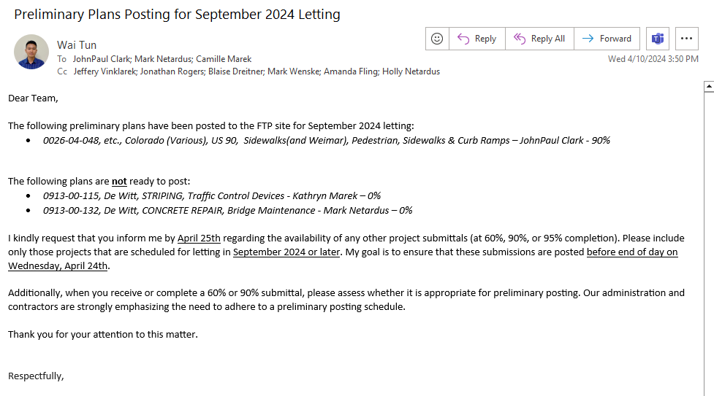
Public Records Request
- Go to Statewide Planning Map.
- Once the location is located in the map, filter the menu of “CONTROL SECTION” to check the CSJ (0000-00).
- Go to Plans-Online (also known as As-Builts) and filter by District, County, and Control Section.
- Download all the required files. (If you can’t find the required files, download all the plans with the same Control (first four digit) and Section (second two digits).
- Go to Box.com from Crossroads and create a folder to upload the files you have downloaded.
- Copy the folder link to send an email to the Public Record Control Coordinator (CC to Engineer Supervisor) with the cloud link.
Note
- Always a disclaimer as: Please note that these as-built and/or construction history data are provided for informational purposes only and does not include any changes in the field as this is an ongoing project.
- If it is for a location map request, include the following disclaimer: Please note that this email contains information based on available records and may be subject to verification.

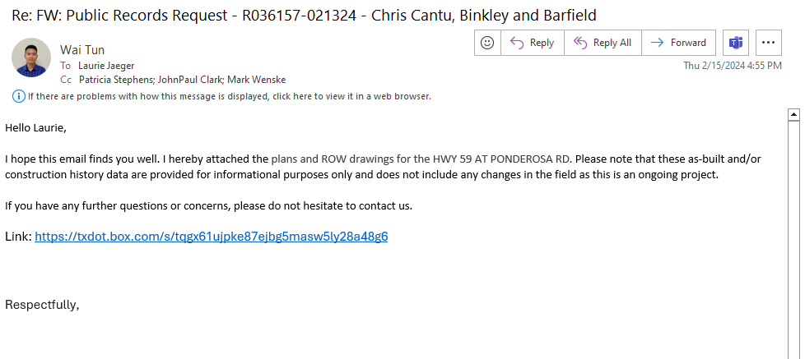

AssetWise (Bridge Inspection Report)
- Go to https://desktop.pingone.com/TxDOT/Selection?cmd=selection to access AssetWise.
- Type the National Bridge Identification (NBI) number at the top right corner.
- Click on “Files” tab.
- Bridge Inspection Files filter from year to year can be found at the left menu.

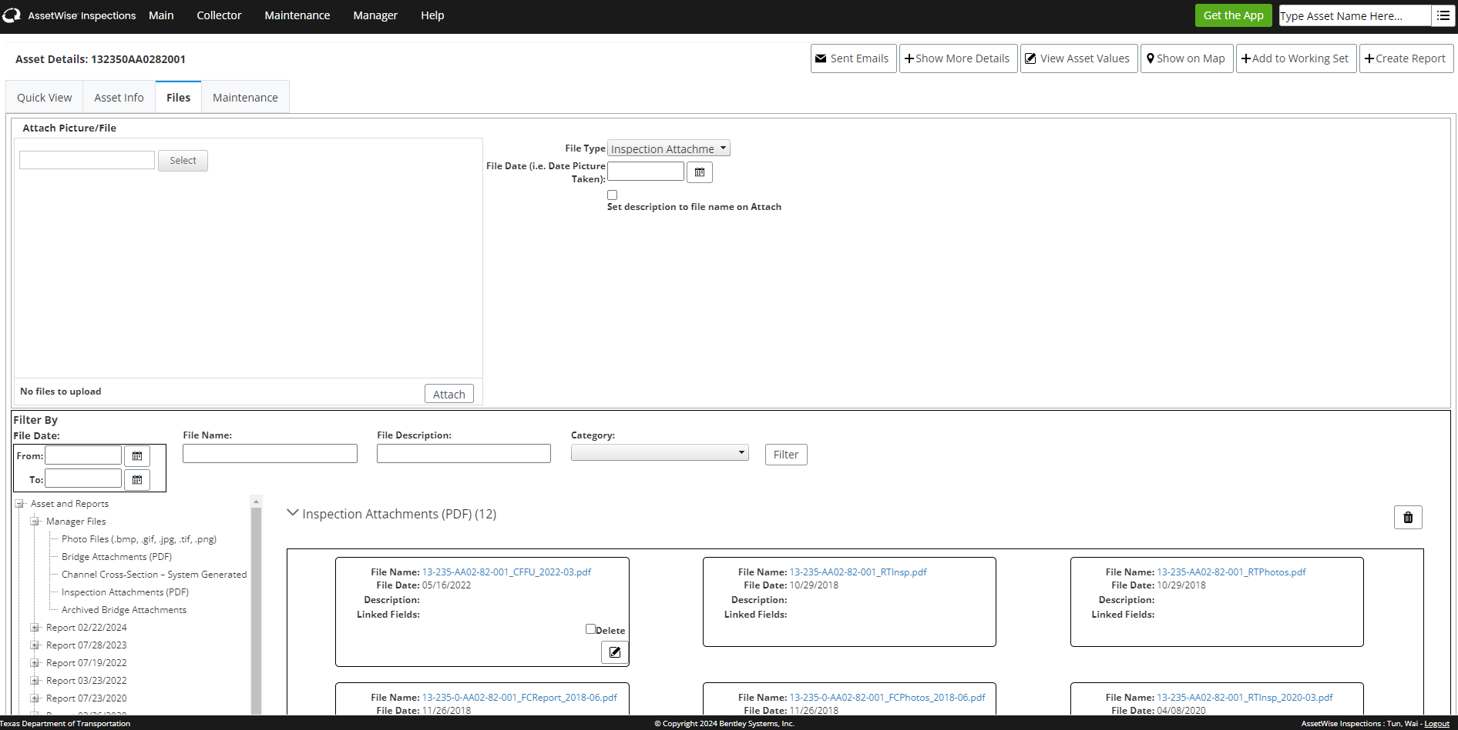

As-Built
In general, As-Builts, also known as Plans-Online, is defined as the construction history data. As-Builts represent a revised set of drawings submitted by a contractor upon project completion. They capture all changes made during construction, reflecting modifications in specifications and working drawings. As-Builts precisely depict the dimensions, geometry, and location of completed work under the contract.
- Control Number: The first four digits represent the control number (destinated system).
- Section Number: The next two digits correspond to the section number, which is typically named after the county.
- Job Number: The last four digits indicate the job number associated with the project.

If multiple jobs are established within the same project, either simultaneously or subsequently, they will share the same control and section numbers but have distinct job numbers1. This ensures consistency and organization in CSJ reporting. Follow these steps using Internet Explorer:
- Navigate to Crossroads.
- Click on the “App” in the top right corner.
- Under the P tab, select “Plans Online – Internal.”
- Within As-builts/finals tab, access the “CST / MNT,” also known as Alchemy Web.
Accurate as-built documentation is crucial for maintaining a project’s lifecycle and ensuring seamless transitions after construction concludes.

Number | County
00 | District Wide
09 | Wharton
17 | DeWitt
18 | Jackson
19 | Calhoun
20 | Austin
21 | Matagorda
22 | Gonzales
26 | Colorado
27 | Victoria
28 | Fayette
29 | Lavaca

Creating A New CSJ
- Cost of the Project:
It is recommended using an estimated cost based on similar projects in most of the time.

- Type of Funding:
Since we are still working on the Preliminary Engineering (PE) phase, we can leave this section blank for now. Additionally, the project is outside of the 10-year window.

- Project Manager:
The project manager has not yet been assigned. For now, we will list Clay as the placeholder. If someone sees that TP&D is listed as the project manager, it indicates the project is still awaiting a formal assignment.

- Design Type (In-house or Consultant):
The design status is still to be determined (TBD). If we need to fill this out and space is limited, please list "In-House" for now.

FPAU NOTE
    - Major Project Above $500,000,000
    - Other Project Between $100 MM to $ 500 MM

Need to highlight- Any Changes

